23CSE111

OBJECT ORIENTED PROGRAMMING

**DOCUMENT**



## Department of computer science Engineering

## Amrita School of Engineering

**Amrita Vishwa Vidyapeetham, Amaravati Campus**

### Name: Bhuvana Harshithaa Vudumula

**Verified By : Roll No: CSEA-24027**

|  |  |  |
| --- | --- | --- |
|  |  |  |

**WEEK - 1**

1. **Write the steps to download and install Java.**

**Aim : Download and Install Java Software**

**Step – 1 : Visit any web browser and search for java download. Select the official Oracle website.**

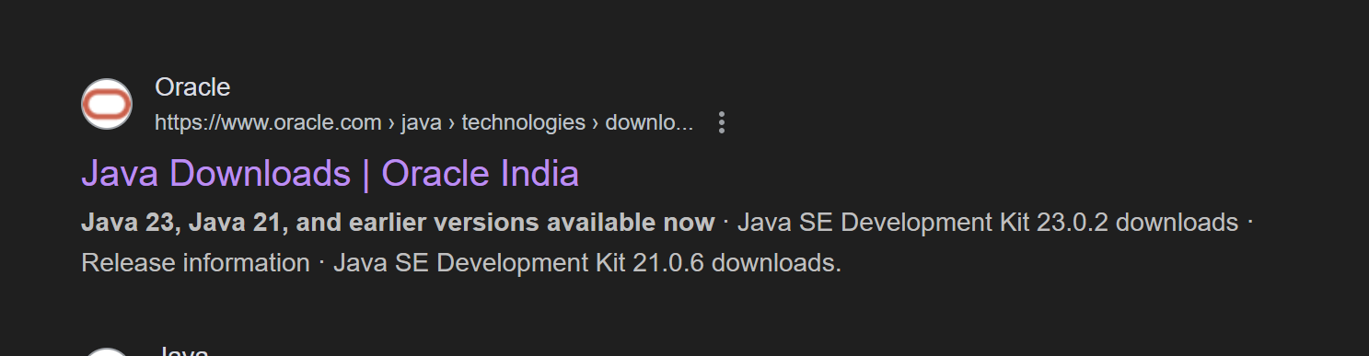

**Step – 2 : Open Oracle website and select the LTS “JDK 21 “ for Windows and select “X64 Installer” and**

**download it.**

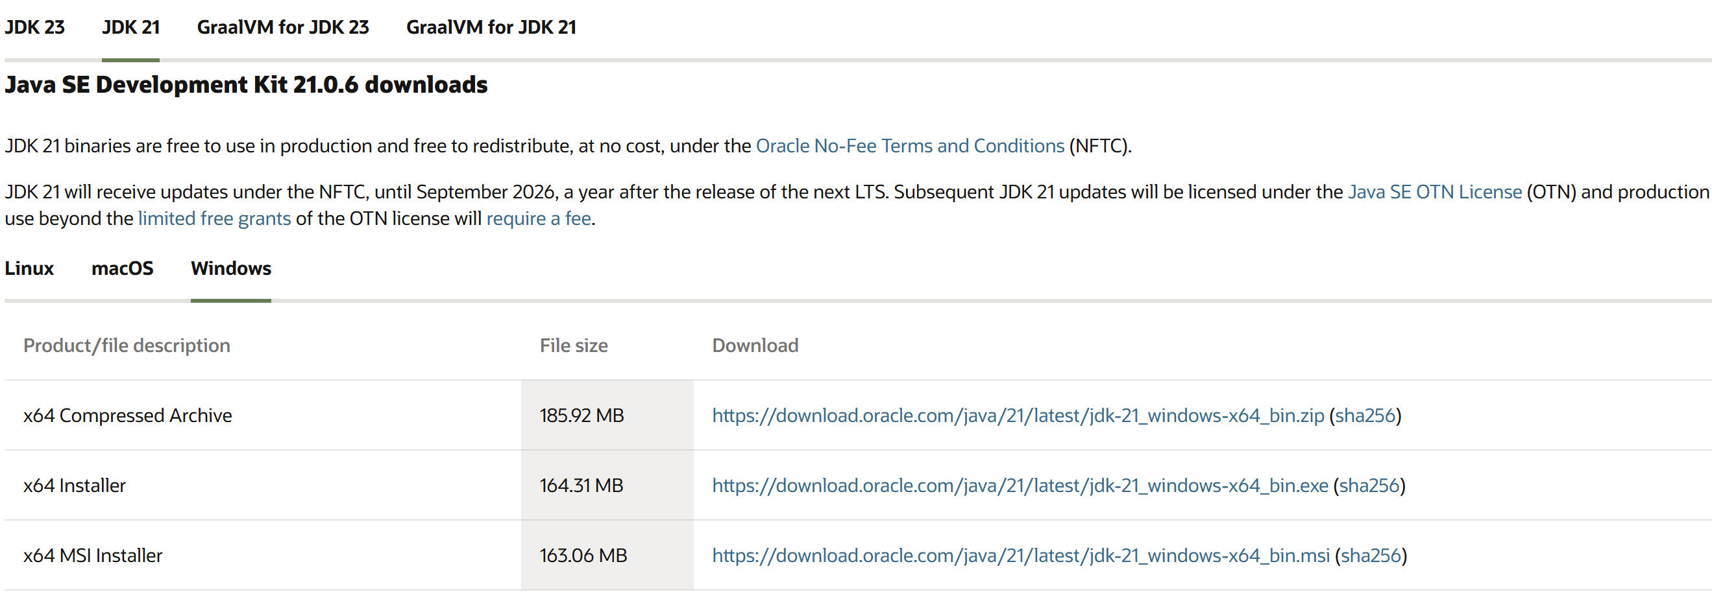

**Step – 3 : After downloading open “C-drive” on your pc and select “Program Files”, open “JDK 21”**

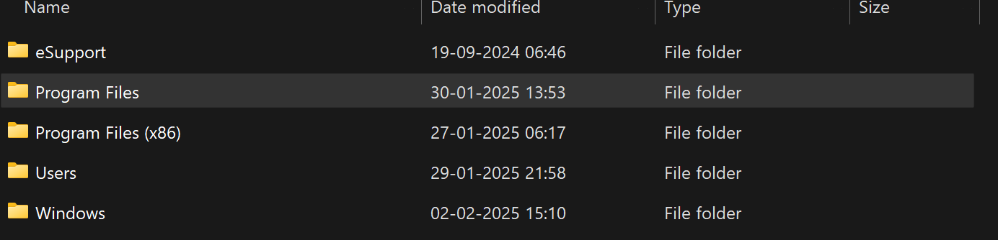

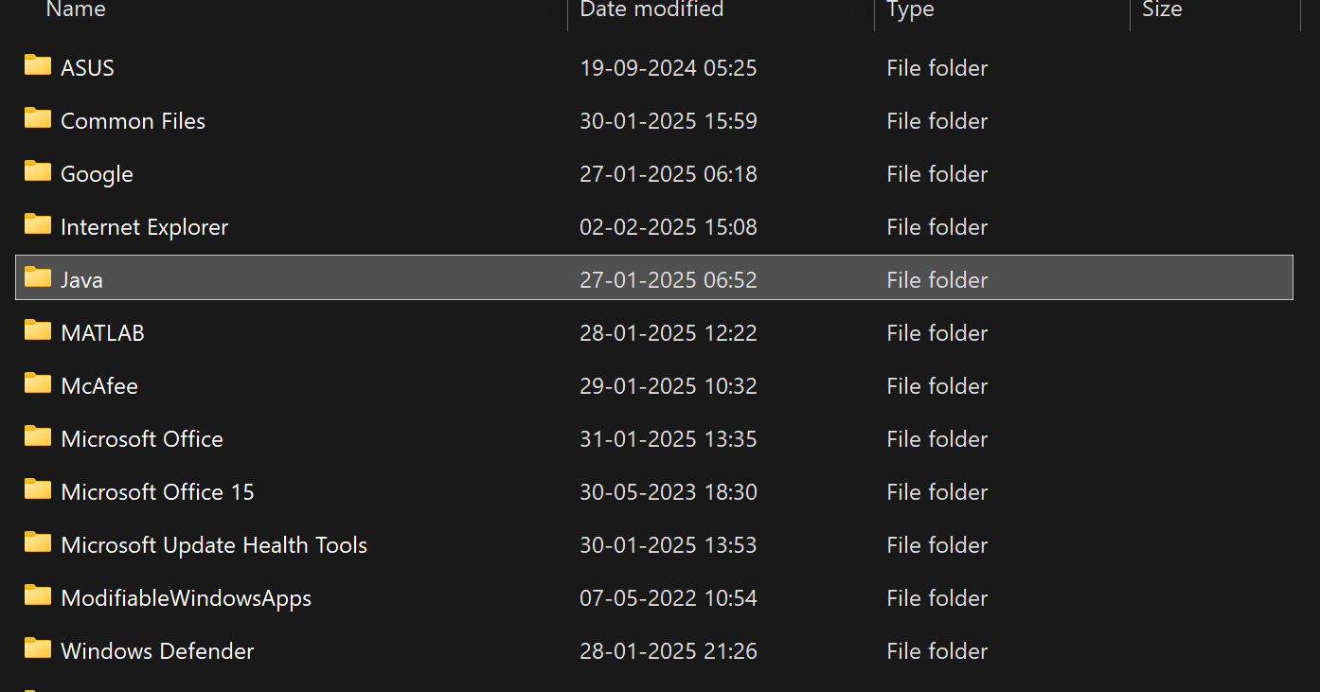



**Step – 4 : Open environmental variables and add a new file with path.**

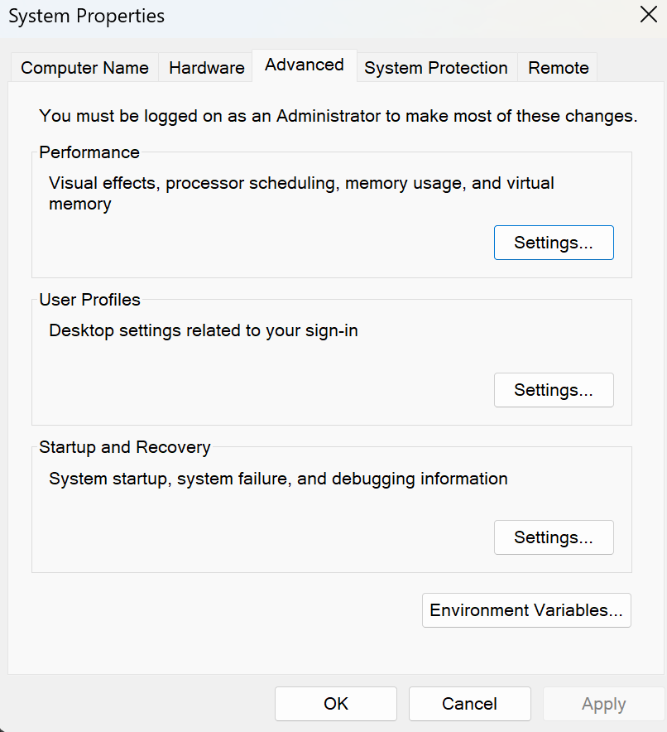

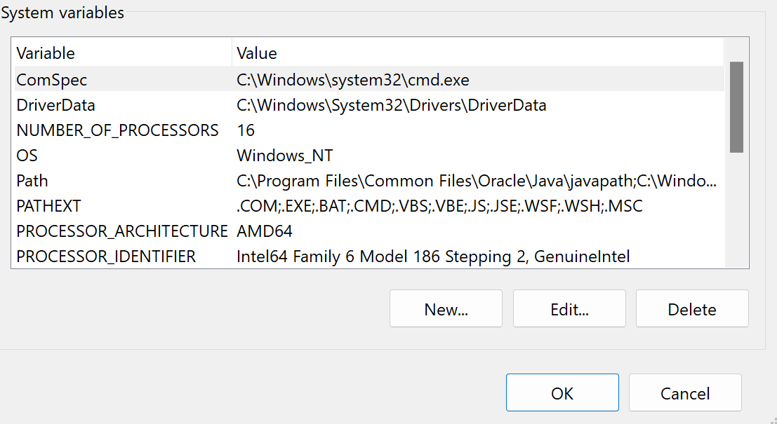

**Step – 5 : Verify java version in command window**

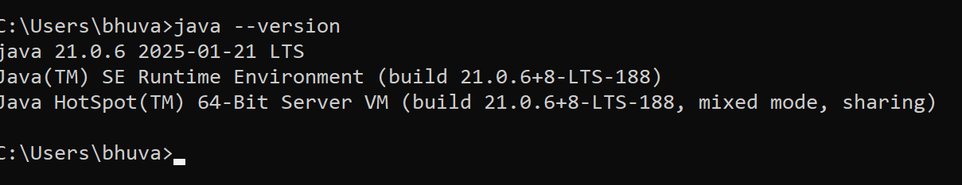

1. **Write a java program to print the message “Welcome to java programming”.**

**Code:**

**class ex1 {**

**public static void main(String[] args) {**

**System.out.println("Welcome to java programming.");**

**}**

**}**

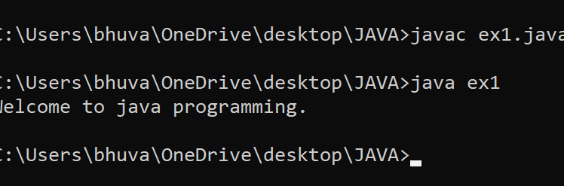

**Error :**

|  |  |  |
| --- | --- | --- |
| **S.No** | **Expected Error** | **Reason** |
| **1** | **;** | **; is expected at end** |
| **2** | **S** | **Capital S is expected for String and System.** |

1. **Write a java program to print the student information**

**Code :**

**class ex2{**

**public static void main(String[] args){**

**System.out.println("Student Information:");**

**System.out.println(“Name : Bhuvana Harshithaa”);**

**System.out.println(“Roll No : 24027”)**

**System.out.println(“Section : CSE A”)**

**}**

**}**

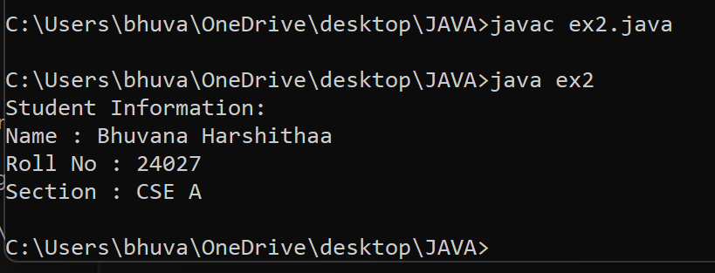

**ERRORS :**

|  |  |  |
| --- | --- | --- |
| **S.No** | **Expected Error** | **Reason** |
| **1** | **;** | **; is expected at end** |
| **2** | **S** | **Capital S is expected for String** |

**WEEK – 2**

1. **Write a java program to clalculate area of rectangle.**

**Code : import java.util.Scanner;**

**public class arear{**

**public static void main(String[] args){**

**Scanner input = new Scanner(System.in);**

**System.out.print("Enter a value : ");**

**int b = input.nextInt();**

**System.out.print("Enter a value : ");**

**int l = input.nextInt();**

**int area = b*l;**

**System.out.print("The area of the rectangle is : "+ area);**

**input.close();**

**}**

**}**

**Output :**

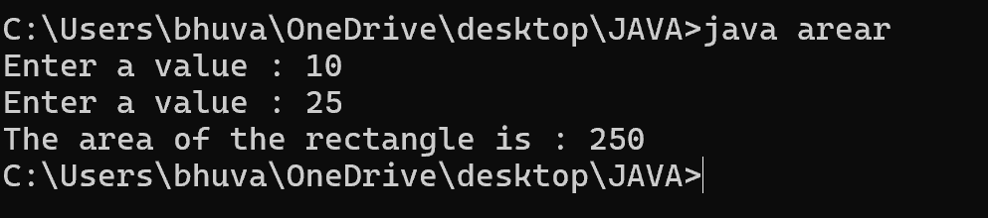

**ERRORS :**

|  |  |  |
| --- | --- | --- |
| **S.No** | **Expected Error** | **Reason** |
| **1** | **;** | **; is expected at end** |
| **2** | **area** | **Declaration of int type variable** |

1. **Write a java program to convert temperature from Celsius to Fahrenheit and vice versa.**

**Code : import java.util.Scanner;**

**class temp{**

**public static void main(String[] args){**

**Scanner input =new Scanner(System.in);**

**System.out.print("enter the the temperature in degrees:");**

**double deg=input.nextDouble();**

**System.out.println("the temperatuer in fahrenheit"+((deg*9/5)+32));**

**}**

**}**

**Output :**

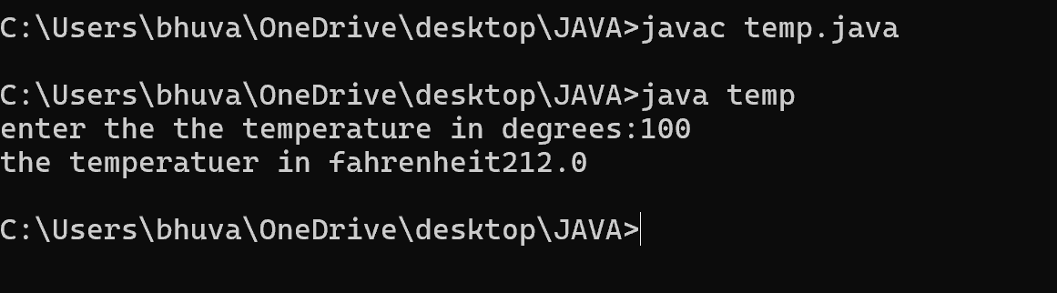

**ERRORS :**

|  |  |  |
| --- | --- | --- |
| **S.No** | **Expected Error** | **Reason** |
| **1** | **;** | **; is expected at end** |
| **2** | **Input.close();** | **The input is expected to be closed.** |

1. **Write a java program to calculate the simple interest.**

**Code : import java.util.Scanner;**

**public class si{**

**public static void main(String[] args){**

**Scanner input = new Scanner(System.in);**

**System.out.print("Enter principal amount : ");**

**int p = input.nextInt();**

**System.out.print("Enter rate of interest : ");**

**int r = input.nextInt();**

**System.out.print("Enter the time period : ");**

**int t = input.nextInt();**

**int SI = p*r*t/100;**

**System.out.print("The simple Interest is : " + SI);**

**input.close();**

**}**

**}**

**Output :**

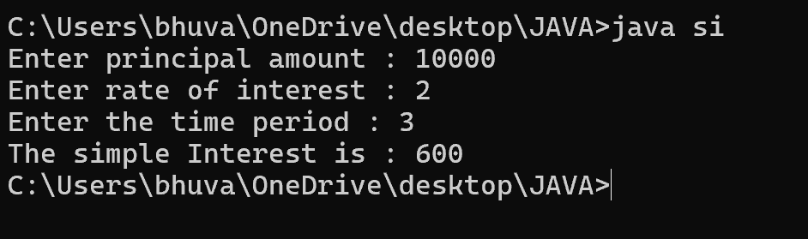

**ERRORS :**

|  |  |  |
| --- | --- | --- |
| **S.No** | **Expected Error** | **Reason** |
| **1** | **;** | **; is expected at end** |
| **2** | **Int t** | **Without declaring t the compiler cannot execute the program.** |

1. **Write a java program to find the largest of three numbers using ternary operation.**

**Code : import java.util.Scanner;**

**public class largest{**

**public static void main(String[] args){**

**Scanner input = new Scanner(System.in);**

**System.out.print("Enter number a : ");**

**int a = input.nextInt();**

**System.out.print("Enter number b : ");**

**int b = input.nextInt();**

**System.out.print("Enter number c : ");**

**int c = input.nextInt();**

**int largest = (a>=b) ? ((a>=c ) ? a : c) : ((b >=c) ? b : c);**

**System.out.print("The largest number is : " + largest);**

**input.close();**

**}**

**}**

**Output :**

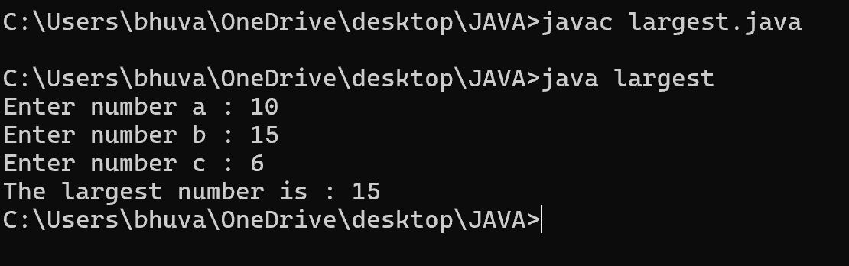

**ERRORS :**

|  |  |  |
| --- | --- | --- |
| **S.No** | **Expected Error** | **Reason** |
| **1** | **?** | **Checks the condition** |
| **2** | **:** | **Comparing between two variables** |

1. **Write a java program to find the factorial of a number**

**Code : import java.util.Scanner;**

**public class fac{**

**public static void main(String[] args){**

**Scanner input = new Scanner(System.in);**

**System.out.print("Enter the number n : ");**

**int n = input.nextInt();**

**int fac = 1;**

**for(int i = 2; i<=n;i++){**

**fac *= i;**

**}**

**System.out.println( "The factorial of the given number is :" + fac);**

**input.close();**

**}**

**}**

**Output :**

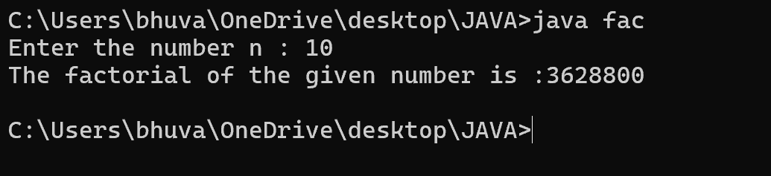

**ERRORS :**

|  |  |  |
| --- | --- | --- |
| **S.No** | **Expected Error** | **Reason** |
| **1** | **}** | **To close for loop** |
| **2** | **System.out.print();** | **If we place the print statement inside the for loop it will print the each i value everytime but to print only the final value we must place it outside the for loop.** |

**WEEK – 3**

1. **Create the java program with the following instructions**
2. **Create a class with name Car**
3. **Create 4 attributes named Car_Color , Car_brand, fuel_type, mileage**
4. **Create 3 method named Start( ) , Stop( ), Service( )**
5. **Create 3 objects Car1 , Car2 , Car3**
6. **Create a constructor which should print “Welcome to Car Garage”**

**Code: public class Car{**

**public String carColor;**

**private String carBrand;**

**private String fuelType;**

**public int mileage;**

**Car(String carColor , String carBrand , String fuelType , int mileage){**

**this.carColor = carColor;**

**this.carBrand = carBrand;**

**this.fuelType = fuelType;**

**this.mileage = mileage;**

**System.out.println(carColor + " " + carBrand + " " + fuelType + " " + mileage);**

**}**

**public void Start(){**

**System.out.println("The car has just started");**

**}**

**public void Stop(){**

**System.out.println("The car has just stopped");**

**}**

**public void Service(){**

**System.out.println("The car is in good condition");**

**}**

**public static void main(String[] args){**

**Car Car1 = new Car("Black","Hyundai","Petrol",100);**

**Car Car2 = new Car("White","Suzuki","Diesel",150);**

**Car Car3 = new Car("Red","Benz","Petrol",200);**

**Car1.Start();**

**}**

**}**

**Output :**

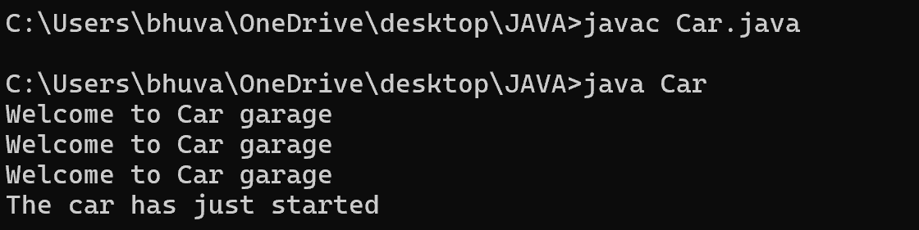

**Errors :**

|  |  |  |
| --- | --- | --- |
| **S.No** | **Expected Error** | **Reason** |
| **1** | **}** | **} is expected at end of the class** |
| **2** | **Setting the parameters inside the constructor** | **We cannot pass the values inside constructor without setting them first** |

**Class Diagram :**

|  |
| --- |
| **Car** |
| **+ carColor : String**  **- carBrand : String**  **- fuelType : String**  **+ mileage : int** |
| **+ Car( ) : void**  **+ Start( ) : void**  **+ Stop( ) : void**  **+ Service( ) : void** |

1. **Write a java program to create a class BackAccount with two methods deposit( ) and withdraw( )**
2. **In deposit( ) whenever an amount is deposited it has to be updated with current amount**
3. **In withdraw( ) whenever an amount is withdrawn it has to be less than current amount else print “Insufficient funds”.**

**Code : public class BankAccount{**

**private String Name;**

**private int AccNo, CurrBal ;**

**BankAccount(String Name, int AccNo, int CurrBal){**

**this.Name = Name;**

**this.AccNo = AccNo;**

**this.CurrBal = CurrBal;**

**System.out.println("The customers are : " + this.Name + " ");**

**}**

**public int deposit(int dAmt){**

**CurrBal = CurrBal + dAmt ;**

**return CurrBal;**

**}**

**public void withdraw(int wAmount){**

**if(wAmount < CurrBal){**

**CurrBal = CurrBal - wAmount ;**

**System.out.println(CurrBal);**

**}**

**else{**

**System.out.println("Insufficient funds");**

**}**

**}**

**public static void main(String[] args){**

**BankAccount Bhuvana = new BankAccount("Bhuvana",1500,10000);**

**Bhuvana.withdraw(13000);**

**Bhuvana.withdraw(1900);**

**int FinalAmount = Bhuvana.deposit(10000);**

**System.out.println(FinalAmount);**

**}**

**Output :**

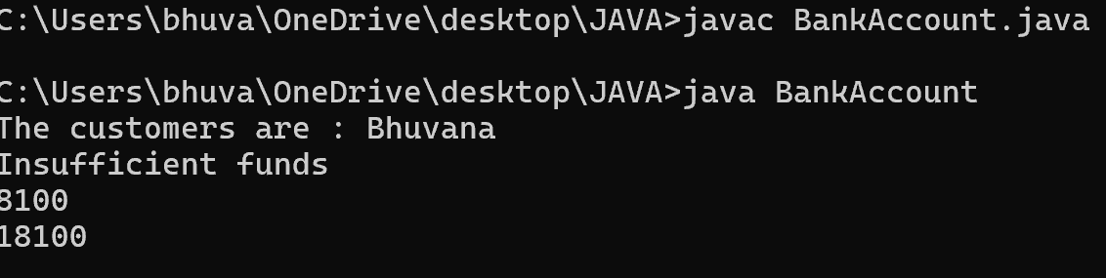

**Errors :**

|  |  |  |
| --- | --- | --- |
| **S.No** | **Expected Error** | **Reason** |
| **1** | **}** | **} is expected at end of the class** |
| **2** | **Setting the parameters inside the constructor** | **We cannot pass the values inside constructor without setting them first** |

**Class Diagram :**

|  |
| --- |
| **BankAccount** |
| **- Name : String**  **- AccNo : String**  **- CurrBal : String** |
| **+ BankAccount( ) : void**  **+ deposit( ) : int**  **+ withdraw( ) : void** |